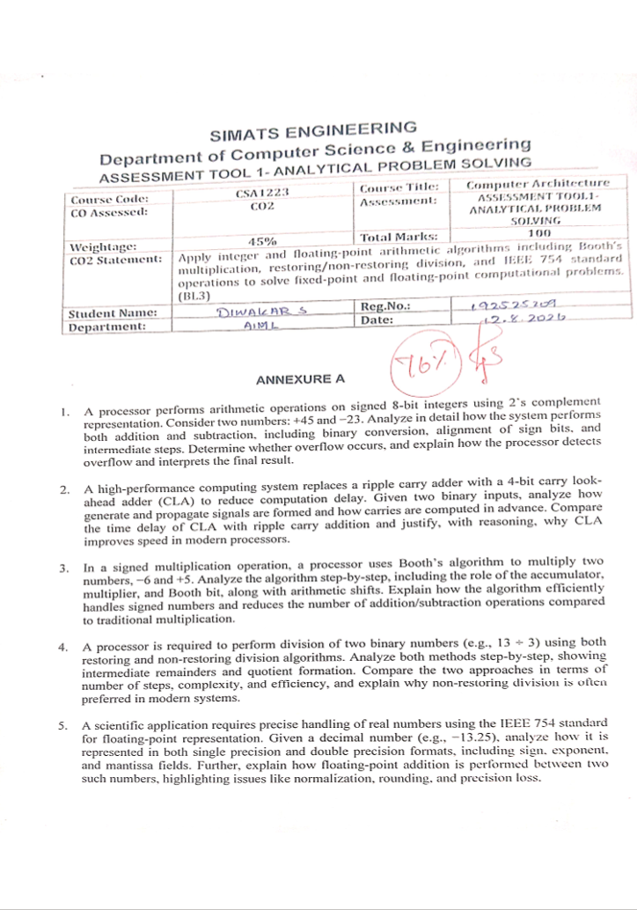
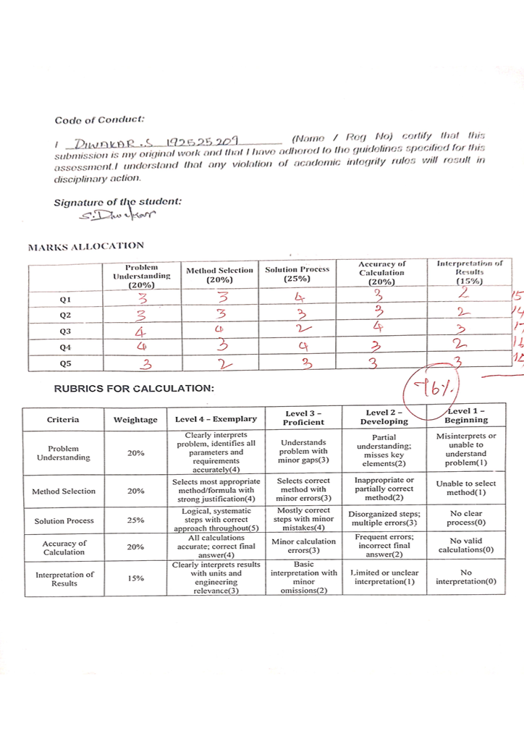

- A program performing signed integer addition using 2’s complement produces incorrect results when adding large values (e.g., +120 and +50 in 8-bit representation). Debug the issue by analyzing the binary computation and identifying whether overflow has occurred. Propose a solution to correctly detect and handle overflow in such cases.

Convert +45 to binary
45 in decimal=32 + 8 + 4 + 1
Therefore +45 = 0010 1101

Step 2: Convert −23 to 2’s complement
First represent +23
23 = 16 + 4 + 2 + 1
+23 = 0001 0111
Take 1’s complement:
1110 1000
Add 1:
1110 1001
Therefore,
−23 = 1110 1001

A. Addition: +45 + (−23)
0010 1101 (+45)
+ 1110 1001 (−23)
----------------
1 0001 0110
Discard the carry beyond the 8th bit:
0001 0110
Convert to decimal:
0001 0110 = 16 + 4 + 2 = 22
Therefore,+45 + (−23) = +22
There is no overflow because the operands have different signs.

B. Subtraction: +45 − (−23)
Subtraction in 2’s complement is performed as:
45 − (−23) = 45 + 23
We have:
+45 = 0010 1101
+23 = 0001 0111
Therefore:
0010 1101
+ 0001 0111
------------
0100 0100
0100 0100 = 68
Therefore,
+45 − (−23) = +68
There is no overflow, because +68 is within the signed 8-bit range:
−128 to +127

Overflow Detection
For signed 2’s complement addition, overflow occurs when:
- Two positive numbers produce a negative result, or
- Two negative numbers produce a positive result.
In 45 + (−23), the operands have different signs, so overflow cannot occur.
In 45 − (−23) = 45 + 23, both operands are positive and the result is +68, which is within the range −128 to +127.

Final Result
Operation | Binary Result | Decimal Result | Overflow
+45 + (−23) | 00010110 | +22 | No
+45 − (−23) | 01000100 | +68 | No

- A processor using a ripple carry adder shows significant delay in executing arithmetic operations in a real-time system. Debug the performance bottleneck by examining how carry propagates through each bit. Suggest an optimized solution using a carry look-ahead adder, and explain how it reduces delay.
Generate:Gᵢ = Aᵢ · Bᵢ
Propagate:Pᵢ = Aᵢ ⊕ Bᵢ
The carry equation is:
Cᵢ₊₁ = Gᵢ + PᵢCᵢ
Consider an example:
A = 1011
B = 0110
Assume initial carry:
C₀ = 0

Step 1: Generate and Propagate Signals
From LSB to MSB:
Bit | Aᵢ | Bᵢ | Gᵢ = AᵢBᵢ | Pᵢ = Aᵢ⊕Bᵢ
0 | 1 | 0 | 0 | 1
1 | 1 | 1 | 1 | 0
2 | 0 | 1 | 0 | 1
3 | 1 | 0 | 0 | 1

Step 2: Calculate Carries in Advance
The carry equations are:
C₁ = G₀ + P₀C₀
C₁ = 0 + (1)(0)
C₁ = 0
Next:
C₂ = G₁ + P₁C₁
C₂ = 1 + (0)(0)
C₂ = 1
Next:
C₃ = G₂ + P₂C₂
C₃ = 0 + (1)(1)
C₃ = 1
Next:
C₄ = G₃ + P₃C₃
C₄ = 0 + (1)(1)
C₄ = 1
Therefore, all carries are determined using combination logic without waiting for one full adder after another.

Step 3: Calculate Sum
The sum equation is:
Sᵢ = Pᵢ ⊕ Cᵢ
Therefore:
S₀ = 1 ⊕ 0 = 1
S₁ = 0 ⊕ 0 = 0
S₂ = 1 ⊕ 1 = 0
S₃ = 1 ⊕ 1 = 0
Therefore:
Sum = 0001
Carry = 1
So:
1011 + 0110 = 1 0001
Decimal verification:
11 + 6 = 17
17 = 10001₂

CLA vs Ripple Carry Adder
In a ripple carry adder, each carry must wait for the previous carry:
C₀ → C₁ → C₂ → C₃ → C₄
Therefore, the delay increases as the number of bits increases.
In a CLA, the carries are calculated simultaneously using generate and propagate signals.
Feature | Ripple Carry Adder | Carry Look-Ahead Adder
Carry calculation | Sequential | In advance
Delay | Higher | Lower
Hardware complexity | Low | Higher
Speed | Slower | Faster
Suitable for | Simple circuits | High-performance processors

Conclusion
CLA improves processor speed because it reduces carry propagation delay. Although it requires additional logic hardware, its faster carry calculation makes it useful in high-performance arithmetic units.

- A multiplication unit implementing Booth’s algorithm gives incorrect results for certain negative operands. Debug the step-by-step execution of the algorithm, focusing on bit-pair checking, arithmetic shifts, and sign extension. Identify the possible source of error and suggest corrections to ensure accurate signed multiplication.
Multiplicand = −6
Multiplier = +5
Using 4-bit representation:
−6 = 1010
+5 = 0101
Let:
- M = 1010 (multiplicand)
- −M = 0110
- A = 0000 (accumulator)
- Q = 0101 (multiplier)
- Q₋₁ = 0
- Number of iterations = 4
Booth decision:
Q₀ Q₋₁ | Operation
00 | No operation
01 | A = A + M
10 | A = A − M
11 | No operation

Step-by-Step Process

Initial
A = 0000
Q = 0101
Q₋₁ = 0
M = 1010

Iteration 1
Q₀Q₋₁ = 10
Therefore:
A = A − M
0000 − 1010 = 0110
Perform arithmetic right shift:
A = 0011
Q = 0010
Q₋₁ = 1

Iteration 2
Q₀Q₋₁ = 01
Therefore:
A = A + M
0011 + 1010 = 1101
Perform arithmetic right shift:
A = 1110
Q = 1001
Q₋₁ = 0

Iteration 3
Q₀Q₋₁ = 10
Therefore:
A = A − M
1110 − 1010 = 0100
Perform arithmetic right shift:
A = 0010
Q = 0100
Q₋₁ = 1

Iteration 4
Q₀Q₋₁ = 01
Therefore:
A = A + M
0010 + 1010 = 1100
Perform arithmetic right shift:
A = 1110
Q = 0010
Q₋₁ = 0

Final Product
Combine A and Q:
A Q = 1110 0010
Therefore:
Product = 11100010₂
Since the result is negative, convert it from 2’s complement.
1’s complement:
00011101
Add 1:
00011110
00011110₂ = 30
Therefore:
11100010₂ = −30
Hence:
−6 × +5 = −30

Advantages of Booth’s Algorithm
- It directly handles signed numbers.
- It uses 2’s complement representation.
- Consecutive 1s in the multiplier can be handled efficiently.
- It reduces unnecessary addition operations.
- Arithmetic right shifting preserves the sign.
- It is suitable for hardware implementation in processors.

Conclusion
Booth’s algorithm efficiently performs signed multiplication. For this problem, the final result is −30, represented as 11100010₂ in 8-bit 2’s complement.

- An embedded system using the restoring division algorithm experiences inefficiency due to repeated restoration steps, leading to increased execution time. Debug the algorithm’s workflow and identify where unnecessary operations occur. Propose an optimized approach using the non-restoring division method, explaining how it improves performance.
Given:
- Dividend = 13 = 1101₂
- Divisor = 3 = 0011₂
- Number of bits = 4

A. Restoring Division
Initial:
A = 0000
Q = 1101
M = 0011
Step | After left shift | A − M | Decision | Final A | Q
1 | A=0001, Q=1010 | 0001−0011 = negative | Restore, Q₀=0 | 0001 | 1010
2 | A=0011, Q=0100 | 0011−0011 = 0 | Q₀=1 | 0000 | 0101
3 | A=0000, Q=1010 | 0000−0011 = negative | Restore, Q₀=0 | 0000 | 1010
4 | A=0001, Q=0100 | 0001−0011 = negative | Restore, Q₀=0 | 0001 | 0100
Therefore:
Quotient = 0100₂ = 4
Remainder = 0001₂ = 1
So:
13 ÷ 3 = 4 remainder 1

B. Non-Restoring Division
Initial:
A = 0000
Q = 1101
M = 0011
Step | Operation | A after operation | Q
1 | Shift, A = A − M | −2 | 1010
2 | Shift, A = A + M | 0 | 0101
3 | Shift, A = A − M | −3 | 1010
4 | Shift, A = A + M | −2 | 0100
At the end, A is negative, so perform the final correction:
A = A + M
−2 + 3 = 1
Therefore:
Quotient = 0100₂ = 4
Remainder = 0001₂ = 1

Comparison
Feature | Restoring Division | Non-Restoring Division
Restoration | Required whenever subtraction is negative | Avoided during intermediate steps
Operations | More add/subtract operations | Fewer correction operations
Hardware | More complex | More efficient
Speed | Relatively slower | Relatively faster
Complexity | Simpler conceptually | Slightly more complex control
Modern use | Less efficient | Often preferred for high-speed implementations

Conclusion
Both algorithms produce:
13 ÷ 3 = 4 remainder 1
Non-restoring division is generally preferred because it avoids immediately restoring the partial remainder after every unsuccessful subtraction, thereby reducing unnecessary operations and improving efficiency.
:::

- A scientific application using IEEE 754 single precision floating-point representation produces inaccurate results when adding very small and very large numbers. Debug the issue by analyzing exponent alignment, normalization, and rounding errors. Suggest optimization techniques, such as using double precision or algorithmic adjustments, to improve accuracy.

Step 1: Convert 13.25 to Binary
Integer part:
13 = 1101₂
Fractional part:
0.25 = 0.01₂
Therefore:
13.25 = 1101.01₂
Normalize:
1101.01 = 1.10101 × 2³
Since the number is negative:
−13.25 = −1.10101 × 2³

A. IEEE 754 Single Precision
Single precision contains:
- Sign = 1 bit
- Exponent = 8 bits
- Fraction/Mantissa = 23 bits
- Bias = 127

Sign Bit
The number is negative:
Sign = 1

Exponent
Actual exponent = 3
Biased exponent:
3 + 127 = 130
130 in binary:
10000010

Fraction
From:
1.10101 × 2³
The leading 1 is implicit, so the fraction field is:
10101000000000000000000
Therefore:
Sign Exponent Fraction
1 10000010 10101000000000000000000
Complete 32-bit representation:
11000001010101000000000000000000

B. IEEE 754 Double Precision
Double precision contains:
- Sign = 1 bit
- Exponent = 11 bits
- Fraction = 52 bits
- Bias = 1023

Sign
1

Exponent
Actual exponent = 3
Biased exponent:
3 + 1023 = 1026
1026 in 11-bit binary:
10000000010

Fraction
Fraction from normalized number:
10101
The remaining positions are filled with zeros:
1010100000000000000000000000000000000000000000000000
Therefore:
Sign Exponent Fraction
1 10000000010 1010100000000000000000000000000000000000000000000000
Thus, −13.25 is represented exactly in both single and double precision because its binary fraction terminates.

C. Floating-Point Addition
Floating-point addition generally follows these steps:

Step 1: Compare Exponents
The exponents of the two floating-point numbers are compared.

Step 2: Align the Mantissas
The number with the smaller exponent is shifted right until both numbers have the same exponent.
Example:
1.xxxxx × 2^m
1.yyyyy × 2^n
The smaller exponent is adjusted so both numbers use the same power of 2.

Step 3: Add or Subtract Significands
After alignment, the significands are added when their signs are the same.
For different signs, the smaller magnitude is subtracted from the larger magnitude.

Step 4: Normalize
The result must be normalized into the form:
1.xxxxx × 2ⁿ
If the result is too large or too small in the significand, the decimal/binary point is shifted and the exponent is adjusted.

Step 5: Rounding
If more bits are produced than the available fraction field, the result must be rounded according to the IEEE 754 rounding mode.
The commonly used default is round to nearest, ties to even.

Step 6: Check Overflow and Underflow
If the exponent becomes too large, floating-point overflow may occur.
If it becomes too small, underflow may occur.

Precision Loss
Precision loss can occur when:
- Exponents are very different.
- A small number is added to a very large number.
- The result contains more fraction bits than can be stored.
- Rounding is required.

Single vs Double Precision
Feature | Single Precision | Double Precision
Total bits | 32 | 64
Sign | 1 | 1
Exponent | 8 | 11
Fraction | 23 | 52
Bias | 127 | 1023
Precision | Lower | Higher

Conclusion
IEEE 754 provides a standardized method for representing real numbers. −13.25 can be represented exactly because its binary representation terminates. Double precision provides a larger exponent range and more fraction bits, so it generally provides greater precision and reduces rounding-related errors compared with single precision.

